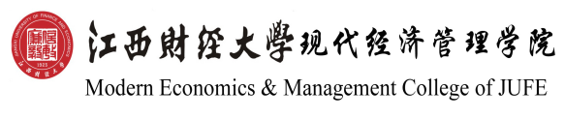
毕业证书

邓XX，男/女，一九九五年三月二十九日生。于二〇一四年九月至二〇一八年七月在江西财经大学现代经济管理学院会计学（注册会计师专门化方向）专业四年制本科学习，修完教学计划规定的全部课程，成绩合格，准予毕业。

校名：江西财经大学现代经济管理学院 校（院）长：王金华
证书编号：134411201805002xxx 二〇一八年七月十日

Certificate of Graduation

This is to certify that Deng XX, male/female, born on March 29th, 1995, has studied from September 2014 to July 2018 majoring in Accounting (CPA Orientation). He/She has completed all the courses prescribed in the 4-year undergraduate teaching program, passed all the exams necessary for graduation from Modern Economics & Management College of JUFE. At the end of the education period with satisfactory performance, he/she is approved graduation.

President: WANG Jin Hua
Modern Economics & Management College of JUFE
Certificate No.: 134411201805002xxx July 10th, 2018

学士学位证书

邓XX，男/女，一九九五年三月二十九日生。在江西财经大学现代经济管理学院会计学（注册会计师专门化方向）专业完成了本科学习计划，业已毕业，经审核符合《中华人民共和国学位条例》的规定，授予管理学学士学位。

江西财经大学现代经济管理学院 学位评定委员会主席：王乔
证书编号：1344142018103xxx 二〇一八年七月十日

Certificate of Bachelor’s Degree

This is to certify that Deng XX, male/female, born on March 29th,1995, has completed undergraduate curriculum in the major of Accounting (CPA Orientation)，Modern Economics & Management College of JUFE. In accordance with “The Regulations Concerning Academic Degrees in the People’s Republic of China”, he/she is awarded the Bachelor’s Degree of Management.

WANG Qiao
Chairman of Degree Awarding Committee,
Modern Economics & Management College of JUFE
Certificate No.: 1344142018103xxx July 10th, 2018

